**Community Congregational Church of Clinton Heights, UCC**

**December 31, 2023**

**Rev. Kathy Johnson**

**Welcome**

**Call to Worship:**

One: We come to the last day of the year.

**ALL: We give thanks to God for all the gifts of the year!**

One: We come after the hustle and bustle of Christmas is over.

**ALL: We give thanks to God for all the gifts of Christmas!**

One: We come looking forward to the new year and the gifts it will bring.

**ALL: Let us worship God.**

**Opening Prayer**

**Dear Gracious and Loving God, we come to you today ready to begin again. We come today ready to open your gifts. We come today to return the gift of love. We come today to be your hands and feet as we give service in the new year. We come today to be your heart and mouth as we give the gift of love in the coming year. May we hear you in our hearts and our minds as begin our worship. In Christ’s name we pray. Amen.**

**Hymn –** All Are Welcome

**Children’s Sermon – The Gift of the Magi Summary**

**Scripture Reading: Matthew 2:1-12**

**Hymn -** Ancient Words

**Sermon: The Gift of Love**

**Hymn –** We Three Kings **(we may have to sing without music? Ok by me)**

**Prayers for others and ourselves**

**Lord’s Prayer** (using debts/debtors)

**Offering**

**Doxology**

**Hymn –** Joyful Joyful We Adore Thee, 2

**Announcements**

**Commission and Benediction Postlude**

**_______________________________________________________________**

**Manage your giving online:**

Community Congregational Church is excited to announce that you can now manage your giving online! Giving online is easy and allows you to set up automatic recurring contributions and view your complete online giving history from anywhere you have access to the Internet. Simply follow these easy steps:

1) Visit the church website at **www.clintonheightsucc.org**,

2) Click on the **Donate Now** button,

3) Click on the **Create Profile** button, then

4) Follow the onscreen instructions to create an online profile and to schedule your recurring contribution.

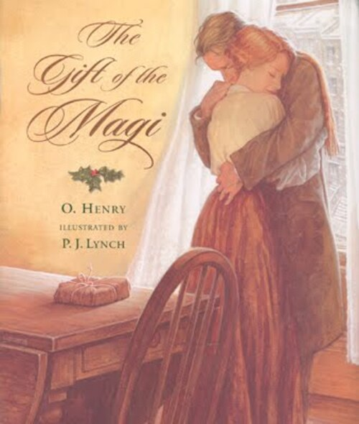

Matthew 2:1-12

The Visit of the Magi

2 In the time of King Herod, after Jesus was born in Bethlehem of Judea, magi[[a](https://www.biblegateway.com/passage/?search=Matthew+2&version=NRSVUE#fen-NRSVUE-23171a)] from the east came to Jerusalem, 2 asking, “Where is the child who has been born king of the Jews? For we observed his star in the east[[b](https://www.biblegateway.com/passage/?search=Matthew+2&version=NRSVUE#fen-NRSVUE-23172b)] and have come to pay him homage.” 3 When King Herod heard this, he was frightened, and all Jerusalem with him, 4 and calling together all the chief priests and scribes of the people, he inquired of them where the Messiah[[c](https://www.biblegateway.com/passage/?search=Matthew+2&version=NRSVUE#fen-NRSVUE-23174c)] was to be born. 5 They told him, “In Bethlehem of Judea, for so it has been written by the prophet:

6 ‘And you, Bethlehem, in the land of Judah,  
    are by no means least among the rulers of Judah,  
for from you shall come a ruler  
    who is to shepherd[[d](https://www.biblegateway.com/passage/?search=Matthew+2&version=NRSVUE#fen-NRSVUE-23176d)] my people Israel.’ ”

7 Then Herod secretly called for the magi[[e](https://www.biblegateway.com/passage/?search=Matthew+2&version=NRSVUE#fen-NRSVUE-23177e)] and learned from them the exact time when the star had appeared. 8 Then he sent them to Bethlehem, saying, “Go and search diligently for the child, and when you have found him, bring me word so that I may also go and pay him homage.” 9 When they had heard the king, they set out, and there, ahead of them, went the star that they had seen in the east,[[f](https://www.biblegateway.com/passage/?search=Matthew+2&version=NRSVUE#fen-NRSVUE-23179f)] until it stopped over the place where the child was. 10 When they saw that the star had stopped,[[g](https://www.biblegateway.com/passage/?search=Matthew+2&version=NRSVUE#fen-NRSVUE-23180g)] they were overwhelmed with joy. 11 On entering the house, they saw the child with Mary his mother, and they knelt down and paid him homage. Then, opening their treasure chests, they offered him gifts of gold, frankincense, and myrrh. 12 And having been warned in a dream not to return to Herod, they left for their own country by another road.