**Palm Sunday**

**Matthew** 21:1-11

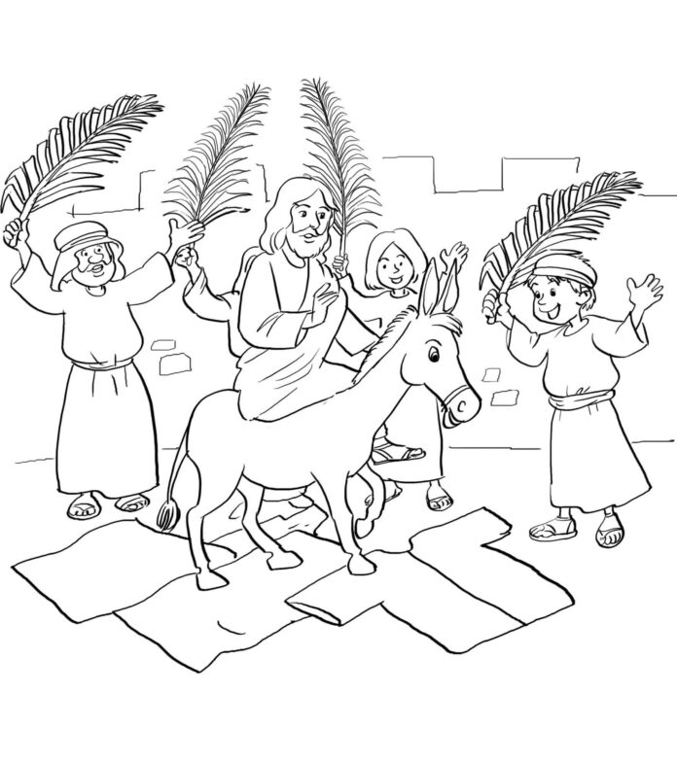

**Monday**

Matthew 21:12-17

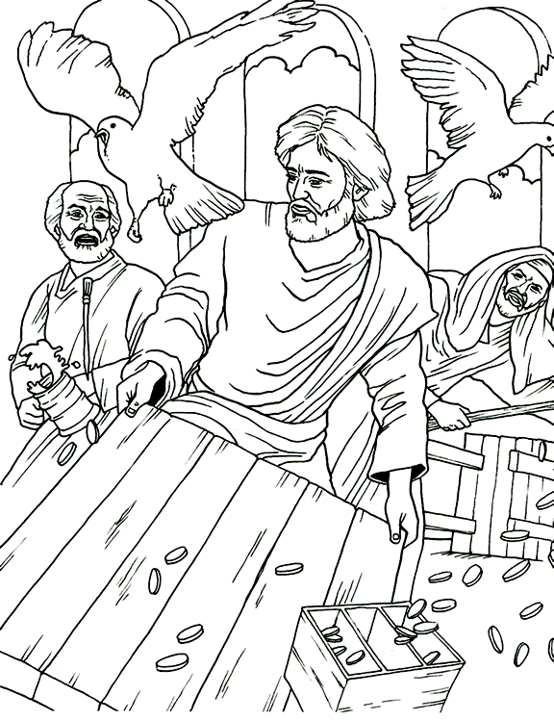

**Tuesday**

Matthew 26:1-16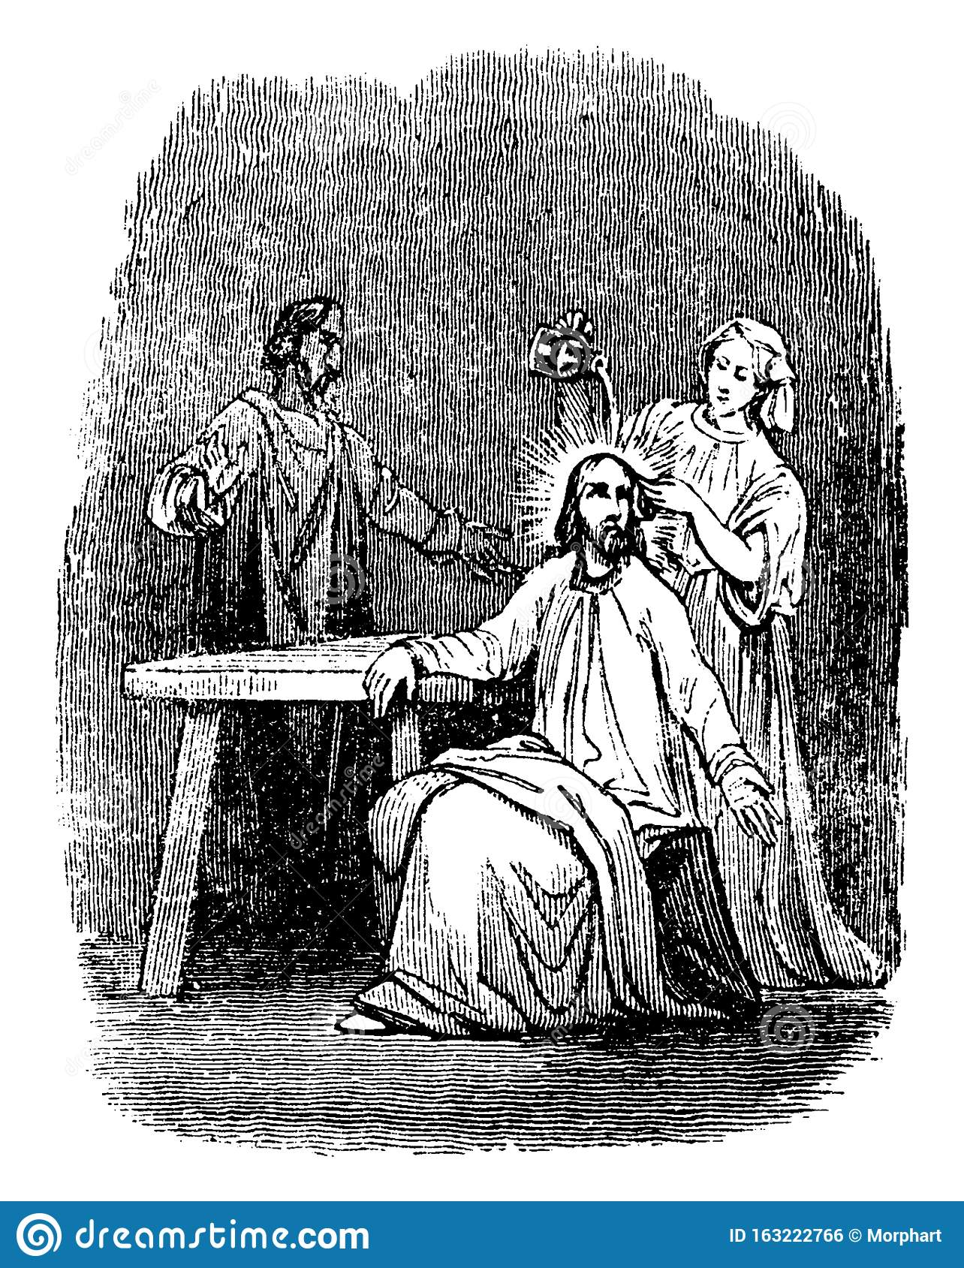

**Wednesday**

Matthew 26:17-25

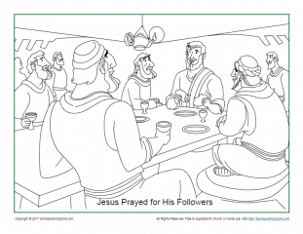

**Thursday**

**Hymn – Here at Thy Table, Lord, 384**

Communion

Matthew 26:26-75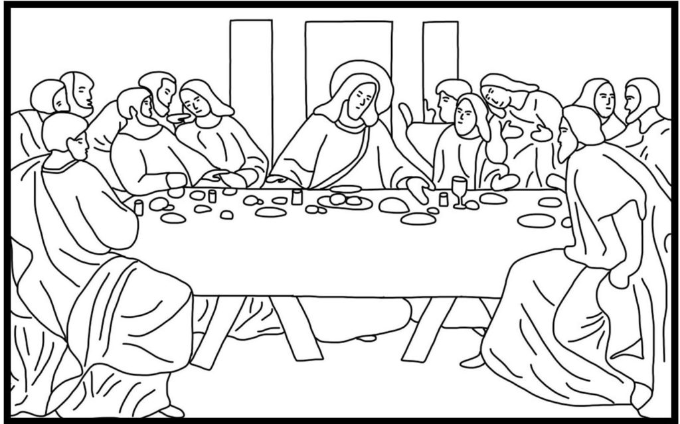

**Friday**

Matthew 27:1-56

