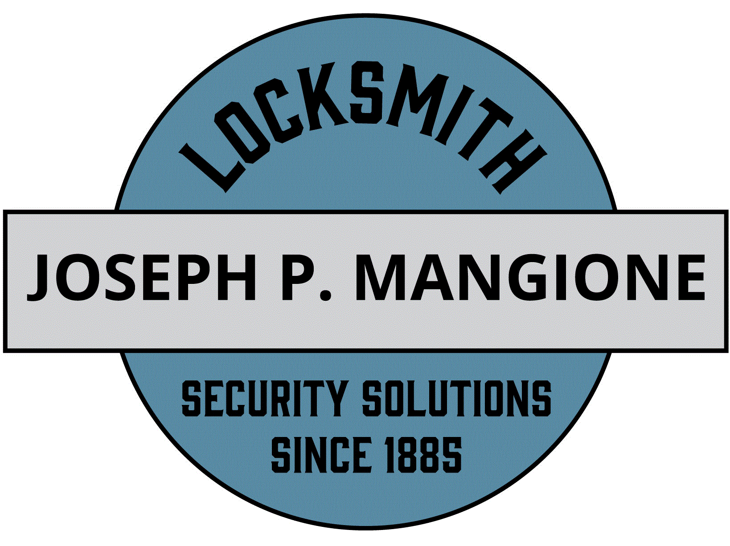

187 Fourth Street

Troy, NY 12180

Phone (518) 272-4080

250 Washington Street

Saratoga Springs, NY 12866

Phone (518) 581-0048

4803 NY-30 Amsterdam, NY 12010

(518) 272-4082

WWW.JPMANGIONE.COM THE ORIGINAL MANGIONE LOCKSMITHS SINCE 1885 NYS LIC#12000288356

***Distributors of***  MEDECO PRODUCTS  
DECORATIVE DOOR HARDWARE

COMMERCIAL DOORS AND FRAMES  
CAMERAS & ACCESS CONTROL SYSTEMS

AUTOMATIC DOOR OPERATORS  
FIRE & BURGLAR SAFES

Community Congregational Church

221 Columbia Turnpike

Rensselaer, NY 12144

August 29, 2023

Per our site visit, we will supply and install one of the following options.

1 Schlage B60 dead bolt

1 Arrow RK keyed knob lock

2 Schlage cylinders for existing locks

All hardware keyed alike with 20 keys

Supplied and installed for $525.00 plus tax.

1 Arrow deadbolt with Medeco patent restricted, high security key cylinder

1 Arrow RK passage knob

2 Medeco patent restricted, high security cylinders for existing locks

All hardware keyed alike with 20 keys

Supplied and installed for $1,260.00 plus tax.

Notes: Medeco keys can only be duplicated at our shop with approved ID.

Please allow 5-10 days for scheduling.

This estimate is valid for 60 days.

Please contact us with any questions, or if you would like to proceed with this estimate.

Joseph P. Mangione Inc.

By: Dan Moss