Order Details #945495

Department Details
East Greenbush, Town of
225 COLUMBIA TPKE
RENSSELAER, NY 12144-4138

Customer Details
trpoole@kc2ivi.com
THOMAS POOLE
221 COLUMBIA TPKE
RENSSELAER, NY 12144-4101
This order was marked as CertCapture Hold on May 10,2023.
# | Image | Model | SKU | Quantity
1 | 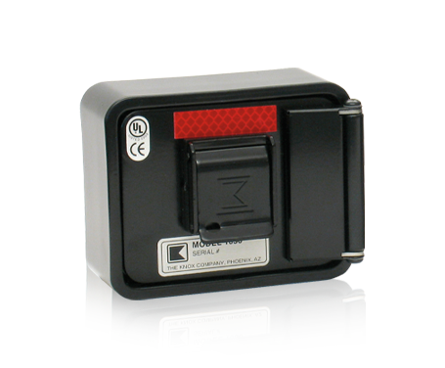 | Model 1658 – Knox Residential Box, Surface Mount, Hinged Door, Black  Model: 1658 | 1658 | 1
Install at: Community Congragational Church, Bldg: NA Rear Entrance off Southern Ave, 221 COLUMBIA TPKE, RENSSELAER, NY 12144-4101
Sub-total
$367.00
Shipping & Handling
$20.00
Tax
$30.96
Total
$417.96
Back To List

