*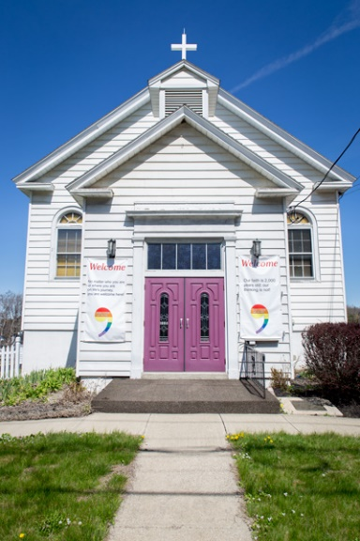Community Congregational Church of Clinton Heights*

Looking for a place to worship?

A place for your group to meet?

A place to socialize?

Contact us for more information or come and visit us for Sunday service @ 10:30 AM. On the first Sunday of the month, join us for fellowship hour after service.

All are welcome!

Call 518-477-4675

Community Congregational Church of Clinton Heights

221 Columbia Tpk. Rensselaer, NY 12144

Email: clintonheightsucc@gmail.com