G

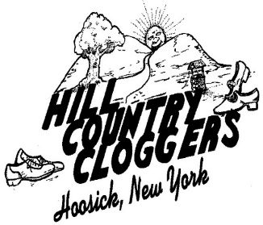

HCC website: [www.hillcountrycloggers.org](http://www.hillcountrycloggers.org/)

Hill Country Cloggers

Proudly Presents

The Beginner Clogging Class Graduation

January 14, 2020

**Graduates**

Dari Brennan

Rita Cedar

Julia Cowan

Elaine Goldman

Rebecca Harrison

Elizabeth Hoerning

**Dance Presentation**

Horse and Buggy All Dancers

Cherokee Boogie Beginner Class & Instructors

Badly Bent Beginner Class & Instructors

Rompin Stompin Group 1 Transition

Shout Mountain Music Group 1

Clap Snap Group 2 (Minis, Juniors & Seniors)

No Excuses Group 2 (Juniors & Seniors)

Do It Like This Senior Competition Team

Walk of Life Beginner Class & Instructors

**Presentation of Diplomas**

Instructor: Fran Beaudoin

*A very special thank you to all of the “angels” who helped with the Beginner Class.*