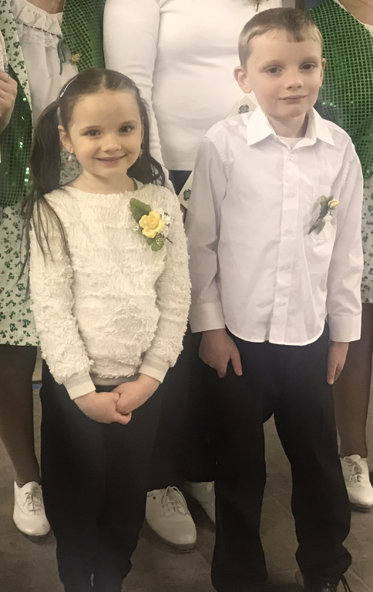

**LEARN TO CLOG DANCE**

**With the Hill Country Cloggers**

**Clogging is type of folk dancing that draws on many different traditions and has evolved into a truly American art form. It is a community – based activity that offers exercise, stress release, and great family fun that appeals to all ages.**

**If you are 7 or older,**

**Come join the Hill Country Cloggers for a:**

**10 Week Beginner Clogging class**

**Date: Tuesday, September 12, 2023**

**Time: 5:45 – 6:30 pm**

**Location: St. Jude’s School Cafeteria**

**42 Dana Avenue, Wynantskill 12198**

**For more information and to register,**

**contact Fran Beaudoin by phone 518-669-4382 (c) or 518-279-3067 (h)**

**or by email at franb@nycap.rr.com**