1. 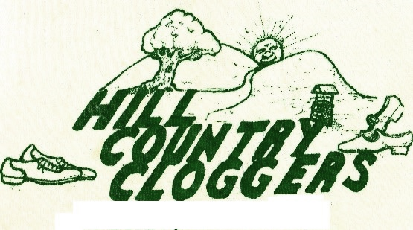
2. **Upstate New York’s Premier Dance Group**

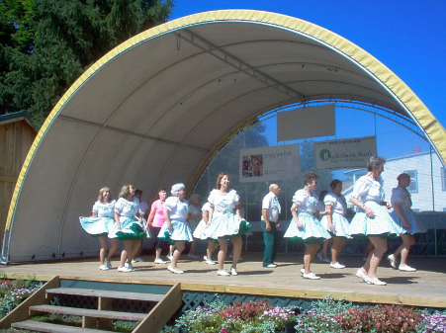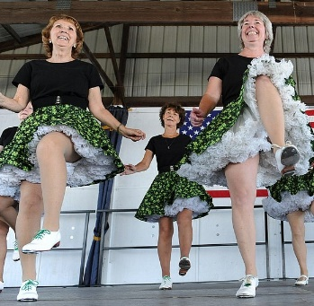The ***Hill Country Cloggers*** came together in 1988 when eight people wanted to spread the joy of clogging. They are also a teaching group and teach clogging in **Hoosick Falls** and **Brunswick**. The group members range in age from 7 years old to 90+ years old. They are a group of men and women with very fast moving feet who have performed all over the capital district at County Fairs, Nursing Homes and many other events. They clog to country music, rock & roll, and even some rap. New Classes for beginners start every September, at both Hoosick Falls and Brunswick.

While they do not charge a fee for our demonstrations, they do accept donations, which is tax deductible as the Hill Country Cloggers are a 501(c)3 non-profit organization. If you are interested in booking the group for a demonstration, please contact Fran Beaudoin at 518-279-3067, or email booking@hillcountrycloggers.org.

Keep in mind; they are always looking for new dancers. You do not need to have any preliminary training.

If you are interested in taking classes and becoming a member, please visit their web page at [www.hillcountrycloggers.org](http://www.hillcountrycloggers.org) or email at [classes@hillcountrycloggers.org](mailto:classes@hillcountrycloggers.org).

1. P.O. Box 204
2. Cropseyville, NY 12052
3. Phone: 518-279-3067
4. Web: www.hillcountrycloggers.org
5. E-mail address: info@hillcountrycloggers.org
6. © Hill Country Cloggers Inc. 2019

**501C3 Non-profit Organization**