Phone: 518-279-3067
P.O. Box 204
Cropseyville, NY 12052

Sign up information
Hill Country Cloggers
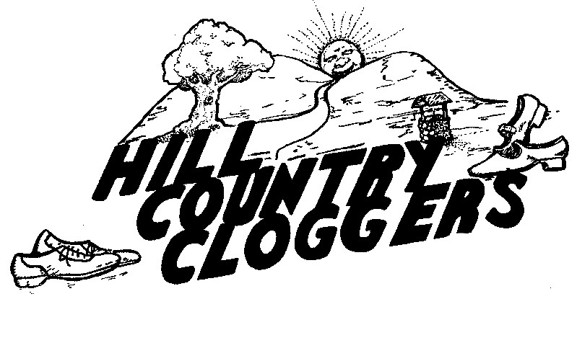
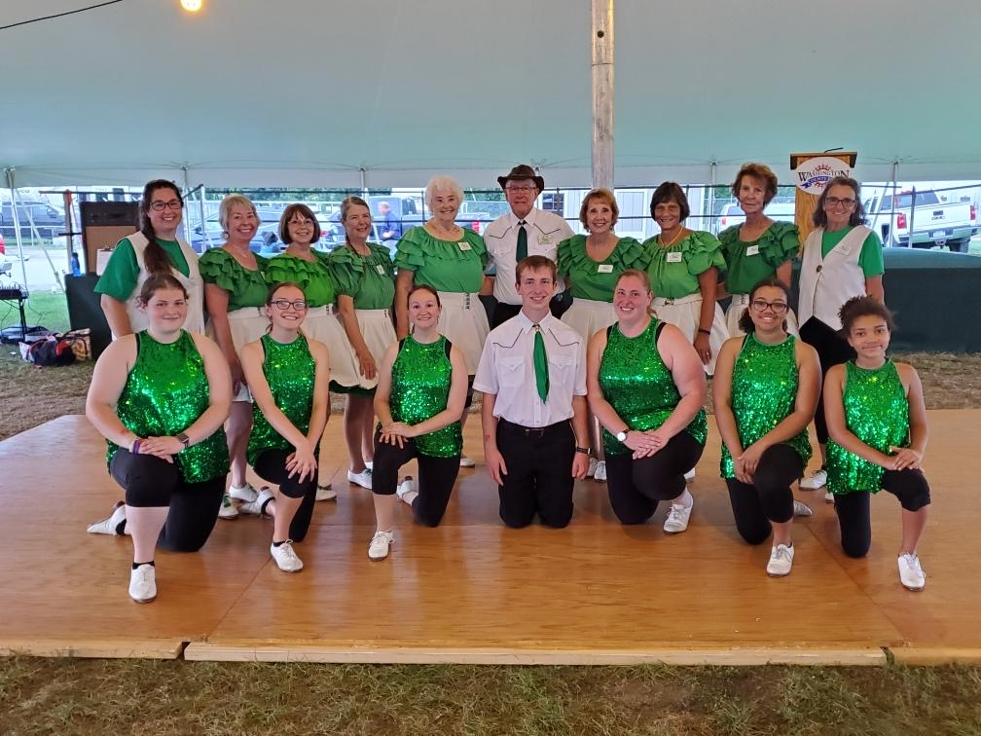

YES!
I am interested in taking classes
NAME: _____________________
ADDRESS: __________________
____________________________
____________________________
PHONE: (____) _____ - ________
EMAIL: _____________________
AGE: ______
You can either hand this completed form to any member of the Hill Country Cloggers or mail to:
Hill Country Cloggers c/o Fran Beaudoin, PO Box 204, Cropseyville, NY 12052 (Please mark “CLASS” on the lower left of the envelope)

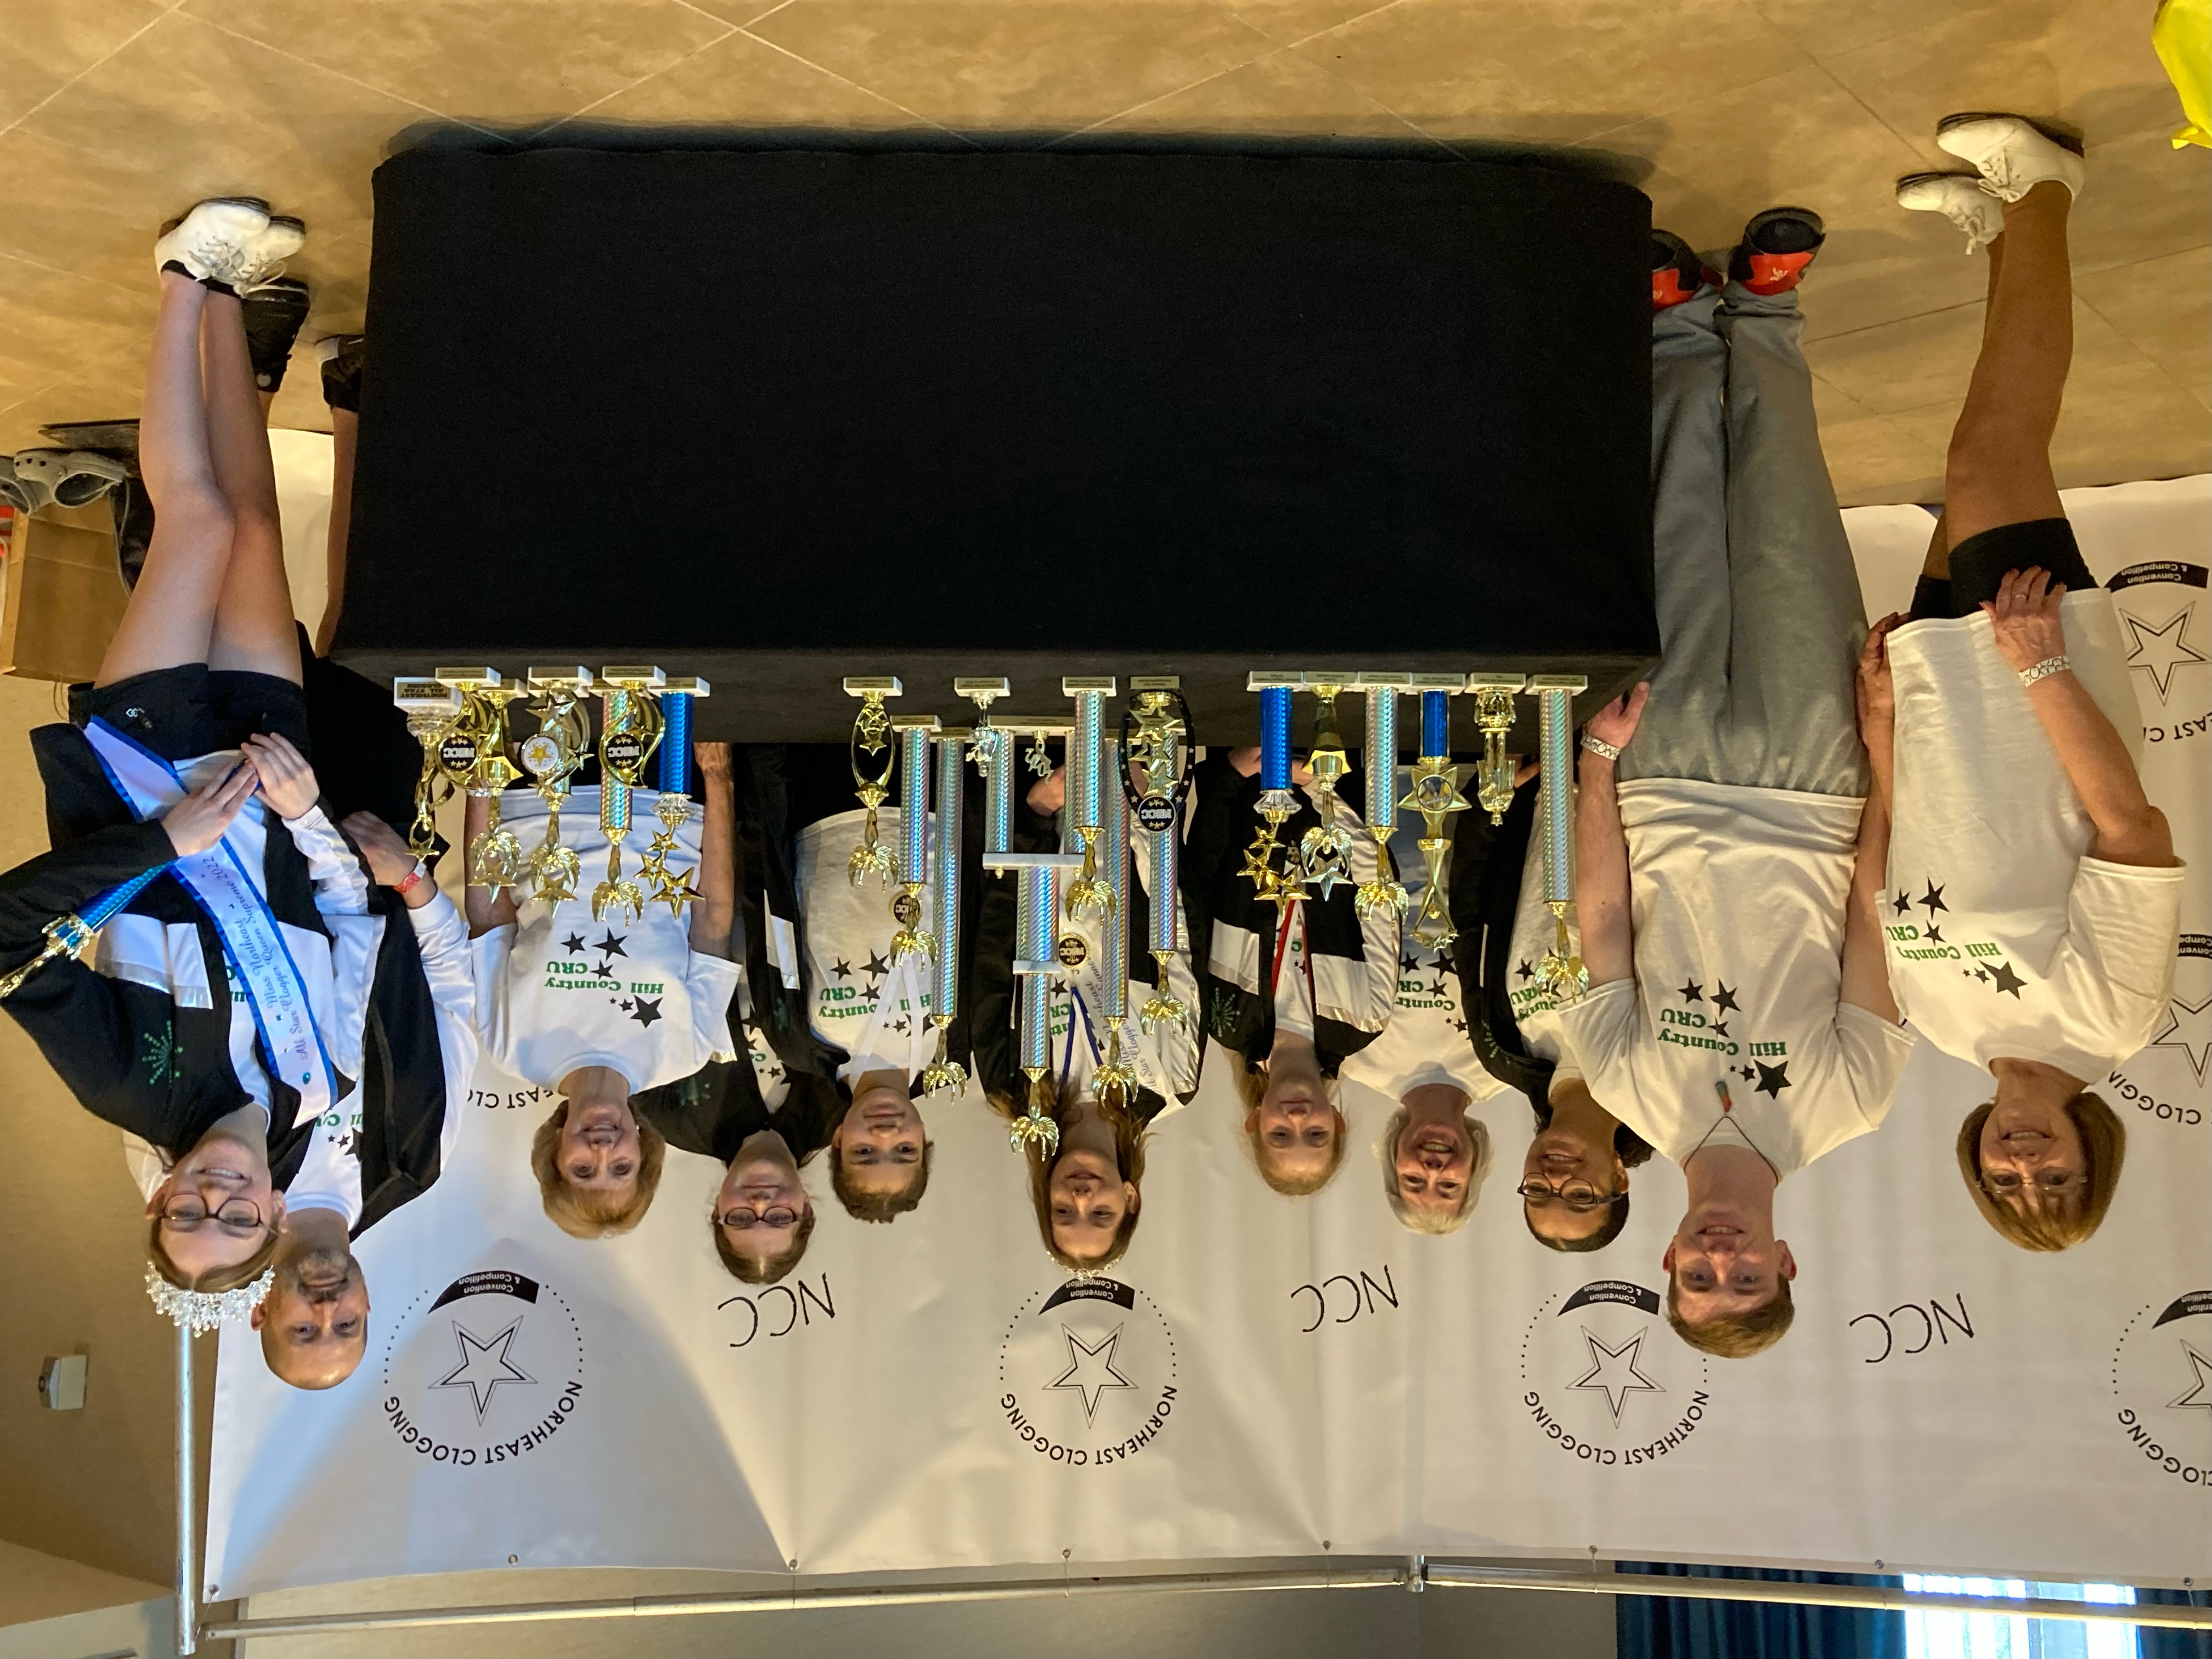

Upstate New York’s

Premier Dance Group

P.O. Box 204
Cropseyville, NY 12052
Phone: 518-279-3067
Web: www.hillcountrycloggers.org
E-mail address: info@hillcountrycloggers.org

© Hill Country Cloggers Inc. 2017
501C3 Non-profit Organization
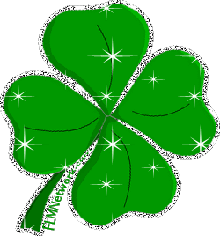

WHAT IS CLOGGING?
As immigrants settled in the Appalachian Mountains, they brought with them their Native dances, styles and music. Some of the dances blended and mixed with other dances to form new styles and dances.
Clogging emerged from a mixture of Irish jigs, English Country dances, German dances, possibly Cherokee Indian, and most certainly African American dances. Add that to the Appalachian flat footing and syncopation dancing and you have what we call the clogging of today.
Traditionally, cloggers danced to bluegrass music, and often still do today. However, many kinds of music from Rock and Pop to Country Western, to oldies, rap, Irish, Christian, or anything that will provide a good dance beat are used today.
Cloggers wear a special set of taps on their shoes to create a unique type of sound.

The Hill Country Cloggers wear a double plated jingle tap with a buck toe so they can make as much noise as possible. Clogging is fun. It contains all the traditions our society needs such as exercise, stress release, community based, positive influence, appeals to all ages, and is good family entertainment. Clogging makes people and those around them smile.

WHO WE ARE!
The Hill Country Cloggers came together in 1988 when eight people wanted to spread the joy of clogging. They are also a teaching group and teach clogging in Hoosick Falls and Brunswick. The group members range in age from 7 years old to 90+ years old. They are a group of men and women with very fast moving feet who have performed all over the capital district at County Fairs, Nursing Homes and many other events. They clog to country music, rock & roll, and even some rap. New Classes for beginners start every September, at both Hoosick Falls and Brunswick.
While we do not charge a fee for our demonstrations, we do accept donations, which are tax deductible as the Hill Country Cloggers are a 501(c)3 non-profit organization. If you are interested in booking our group for a demonstration, please contact Fran Beaudoin at 518-279-3067, or email booking@hillcountrycloggers.org.
Keep in mind; we are always looking for new dancers. You do not need to have any preliminary training.
If you are interested in taking classes and becoming a member, please fill out the form on the back of this brochure or visit our web page at www.hillcountrycloggers.org.

