HILL COUNTRY CLOGGERS LAUNCHES ITS COMPETITION TEAM.

Led by premier clogger Taylor Johnston, the team will participate in performances at clogging conventions throughout the Northeast.

Taylor has taught clogging to children and adults, has clogged competitively for 14 years and choreographed competition routines for 10 years. She knows what it takes to create winning numbers while having fun. Her goal for the competition team is to encourage all dancers to strive for their best and to improve from one competition to the next.

Dancers will have the opportunity to perform for large crowds and compete against many other teams while developing positive self esteem, confidence and leadership skills.

If you are interested in learning more about the Hill Country Clogger’s Competition Team, please email us at www.competitionteamhillcountrycloggers.org

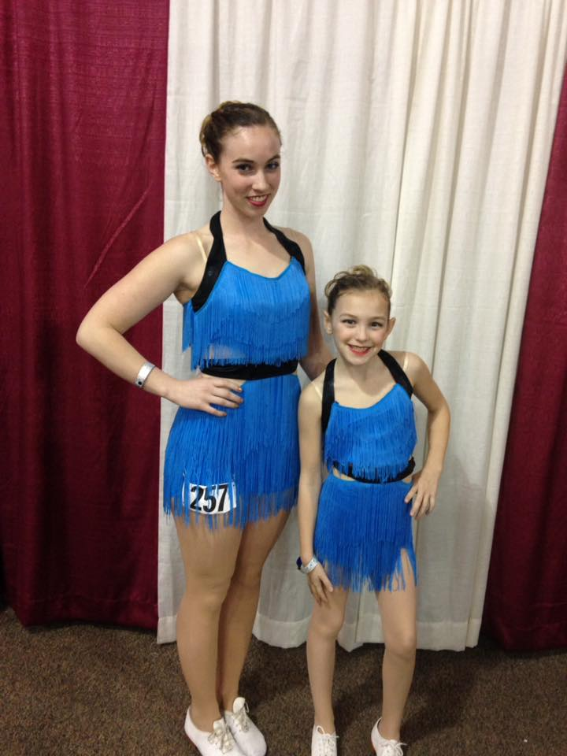

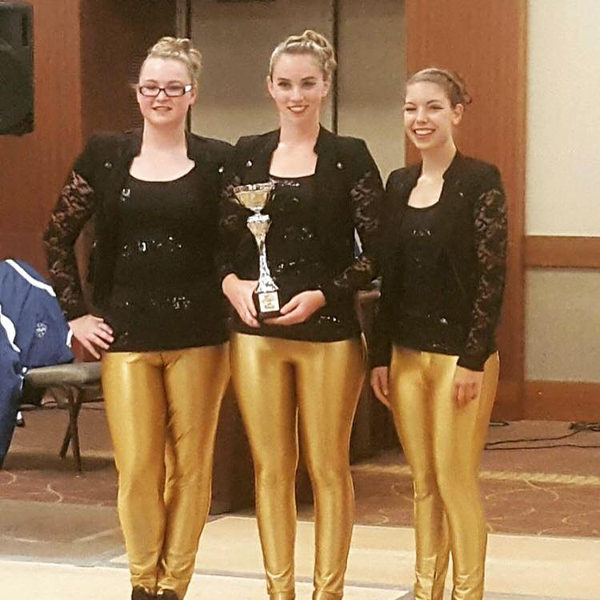  
 Taylor and Hannah at NECC 2017 Samantha, Taylor and Brandy at 2016

Clogging Convention Salt City Festival & Clogging Convention