G

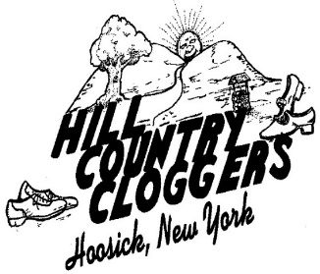

HCC website: [www.hillcountrycloggers.org](http://www.hillcountrycloggers.org/)

Hill Country Cloggers

Proudly Presents

The Beginner Clogging Class Graduation

March 3, 2022

**Graduates**

Jill Gresens

Amy Modesti

Peter Spellman

Therese Spellman

**Dance Presentation**

Horse and Buggy All Dancers

Cherokee Boogie Beginner Class & Instructors

Badly Bent Beginner Class & Instructors

Down at the Twist & Shout Transition & Demo Dancers

Bop Beginner Class & Instructors

Walk of Life Beginner Class & Instructors

It’s Not Unusual All Dancers

Cock of the North Competition Team Dancers

I’ll Fly Away Demo Dancers

Forever & Ever Amen All Dancers

**Presentation of Diplomas**

Instructor: Fran Beaudoin

*A very special thank you to the “angels” who helped with the Beginner Class*