*TWO HILLBILLIES*

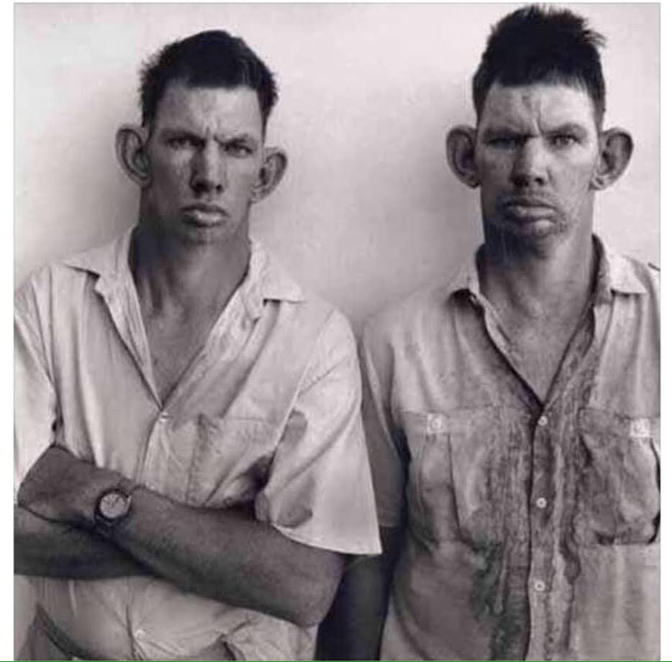

Two hillbillies walk into a restaurant.

Whilst having a bite to eat they talk about their moonshine operation.

Suddenly a woman at a nearby table, who is eating a sandwich, begins to cough.

After a short while it becomes apparent that she is in distress.

One of the hillbillies looks at her and asks “Kin ya swallar?” The woman begins to turn blue and shakes her head No.

He then asks, "Kin ya breathe?" The woman shakes her hear No!

The hillbilly walks over to the woman, lifts up her dress, yanks down her drawers and quickly gives her right butt cheek a lick with his tongue.

The woman is so shocked, she has a violent spasm and the obstruction flies out of her mouth.

As she begins to breathe again the hillbilly walks back to his table and his partner says “Ya know, I’d heerd of that there Hind Lick Maneuver but I’d never seed nobody done it”